Review of Compliance Tool – Tunisia
Review date: July 16, 2026
- It seems that the tool is not adapted to required dimensions for the shapes illustrated in Figures and thus several issues with the provided illustrations such as T-shape. The screen asks for Y3 even though no Y3 is needed in the illustration as noted below:

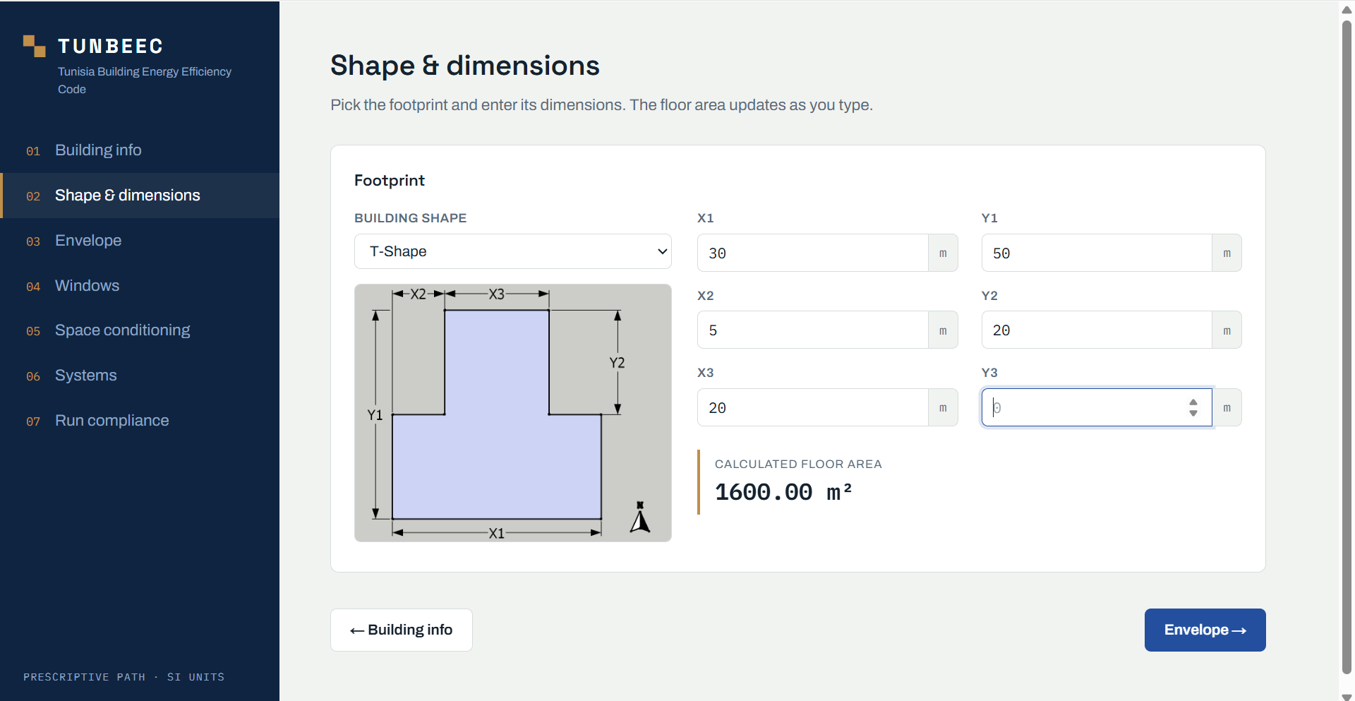

- Similar to this illustration for the shading features (label are not aligned and not visible in the current version of the tool):
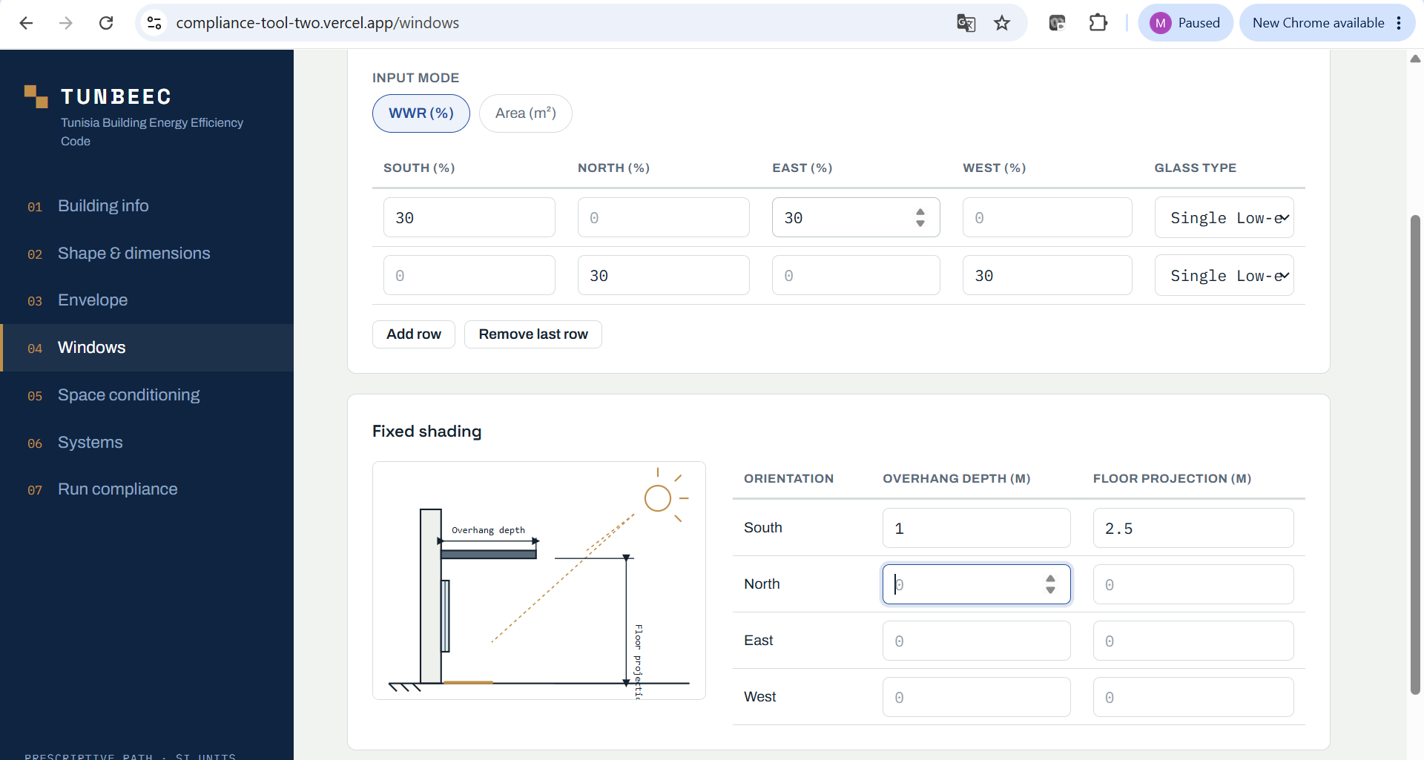

Here is the provided illustration for the shade parameter (French but can google translated!) that was provided with the old version of the compliance tool:
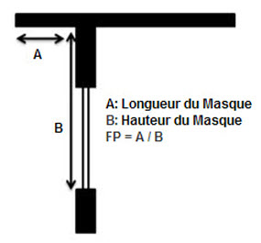

- This screen should be related to internal load for spaces rather than air conditioned spaces only. Try to use the same screen titles as the offline tool.
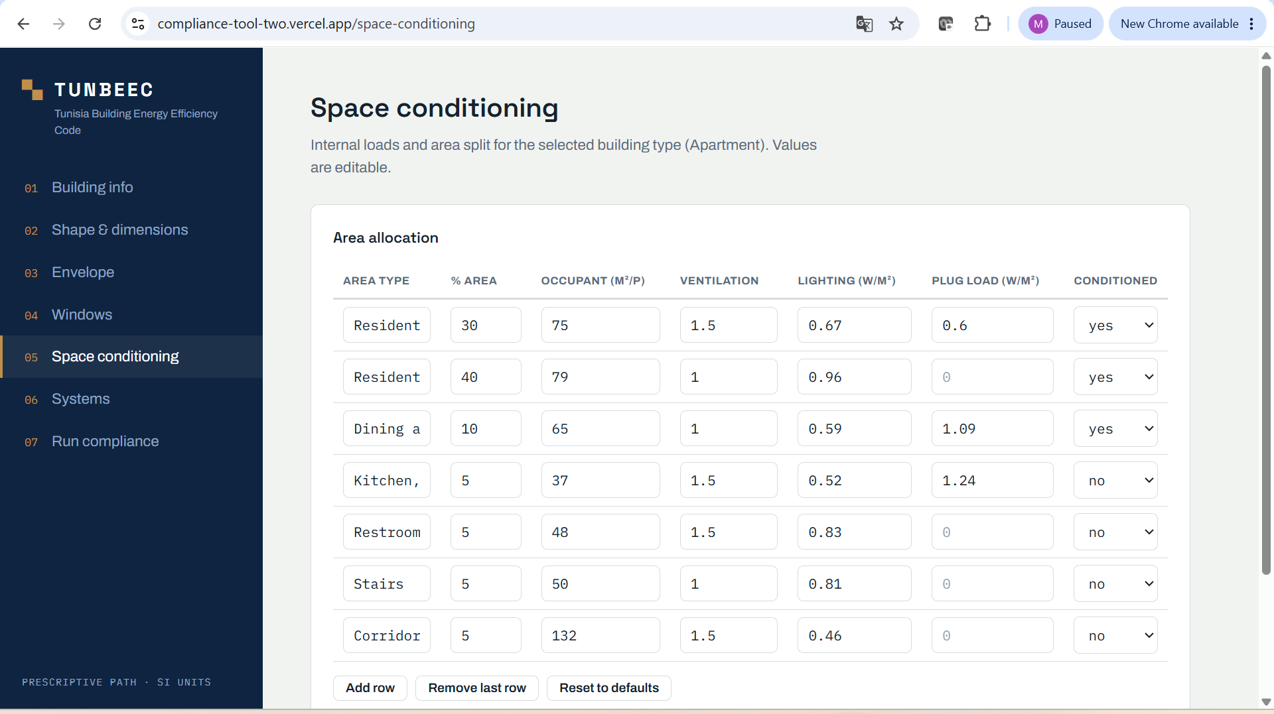

- Add illustrations for the selected HVAC systems as provided in the old version for various types of HVAC.
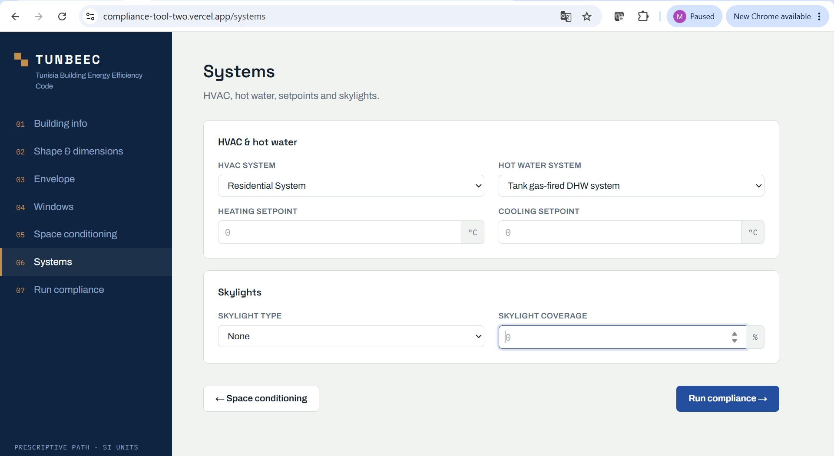
- This may the most important issue: The online tool like the offline tool should be able to perform the performance compliance using the simulation tool. It should be possible to connect the online tool to run in the background the simulation tool (KBEAT tool uses the same DOE2.2 simulation engine). Otherwise, this online tool is not useful! Let us discuss this issue if there is an issue of running DOE2.2.

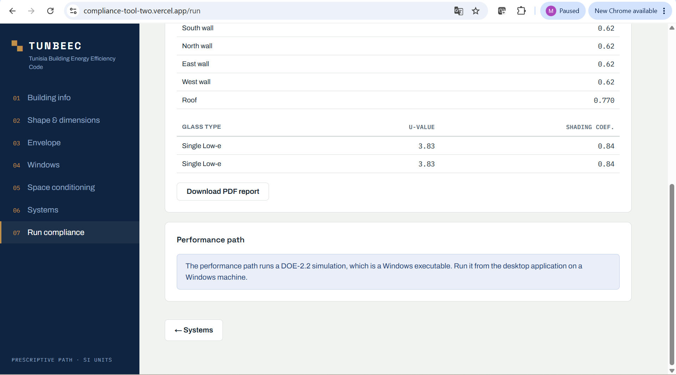
- The compliance report should be like the old version as noted below:

